Checkpoint 11.1

Question 1
What is a modem ? Name two categories of modems.
Answer
Modem stands for Modulator DEModulator. It is a computer peripheral device that allows us to connect and communicate with other computers via telephone lines.
Modems come in two varieties :
- Internal modems — They are fixed within the computer.
- External modems — They are connected externally to a computer as other peripherals are connected.

Question 2(i)
Define RJ-45.
Answer
RJ-45 refers to Registered Jack-45. It is an eight-wire connector, which is commonly used to connect computers on the local area networks (LANs), especially Ethernets.

Question 2(ii)
Define Ethernet.
Answer
Ethernet is a LAN architecture developed by Xerox Corp along with DEC and Intel. Ethernet uses either a bus or star topology and supports data transfer rates of upto 10 Gbps. Ethernet can connect devices in wired LAN or WAN.

Question 2(iii)
Define Ethernet card.
Answer
Ethernet Card is a type of Network Interface card, which is specific to Ethernet technology. An Ethernet card contains connections for either coaxial or twisted pair cables or both.

Question 2(iv)
Define hub.
Answer
A hub is a networking device having multiple ports that are used for connecting multiple computers or segments of a LAN together.

Question 2(v)
Define switch.
Answer
A switch is a device that is used to segment networks into different sub-networks, called subnets or LAN segments.

Question 3(i)
Define host.
Answer
A host or node refers to the computers that are attached to a network and are seeking to share the resources of the network.

Question 3(ii)
Define repeater.
Answer
A repeater is a network device that amplifies and restores signals for long-distance transmission.

Question 3(iii)
Define bridge.
Answer
A bridge is a device that links two networks together. Bridges are smart enough to know which computers are on which side of the bridge, so they only allow those messages that need to get to the other side to cross the bridge. Bridges can handle networks that follow same protocols.

Question 3(iv)
Define router.
Answer
A router is a network device that forwards data from one network to another. A router works like a bridge but can handle different protocols.

Question 3(v)
Define gateway.
Answer
A gateway is a network device that connects dissimilar networks. It establishes an intelligent connection between a local network and external networks with completely different structures.

Question 4
What is the purpose of using a gateway in context of networking ?
Answer
Gateways relay packets among networks that have different protocols (e.g., between a LAN and a WAN). They accept a packet formatted for one protocol and convert it to a packet formatted for another protocol before forwarding it.

Question 5
What is the purpose of using a repeater in context of networking ?
Answer
A repeater is a network device that amplifies and restores signals for long-distance transmission. It is used in long network lines, which exceed the maximum rated distance for a single run.
Over distance, the cables connecting a network lose the signal transmitted. Repeaters are installed along the way in the network to ensure that data packets reach their destination without any degradation of the message.

Checkpoint 11.2

Question 1
Briefly explain file transfer protocol.
Answer
File Transfer Protocol is a standard for the exchange of files across internet. Files of any type can be transferred, whether the file is an ASCII or binary file. They can be transferred to any system on the Internet provided that permissions are set accordingly.
The main objectives of FTP are as follows:
- to promote sharing of files (computer programs and/or data)
- to encourage indirect or implicit (via programs) use of remote computers
- to shield a user from variations in file storage systems among hosts
- to transfer data reliably and efficiently.

Question 2
What is protocol ? Name some commonly used protocols.
Answer
A protocol is a formal description of message formats and the rules that two or more machines must follow to exchange those messages.
Some commonly used protocols are as follows:
- HTTP (Hypertext Transfer Protocol)
- FTP (File Transfer Protocol)
- TCP/IP (Transmission Control Protocol/Internet Protocol)
- Slip (Serial Line Internet Protocol) / PPP (Point to Point Protocols)
- IMAP (Internet Message Access Protocol)
- POP (Post Office Protocol)
- SMTP (Simple Mail Transfer Protocol)

Question 3
What is TCP/IP ? What is HTTP ?
Answer
TCP/IP (Transmission Control Protocol/Internet Protocol) is the base communication protocol of the Internet. IP part of TCP/IP uses numeric IP addresses to join network segments and TCP part of TCP/IP provides reliable delivery of messages between networked computers.
HTTP (Hypertext Transfer Protocol) is the set ot rules for transferring hypertext, like text, graphic, image, sound, video etc., on World Wide Web.

Question 4
Define Mobile Communication and Wireless Communication.
Answer
Mobile communication means that the computing device is not continuously connected to the base or central network. Mobile computing does not necessarily require wireless communication. It may not require communication between devices at all.
Wireless communication refers to the method of transferring information between a computing device and a data source without a physical connection.

Question 5(i)
Define GSM.
Answer
GSM refers to Global System for Mobile communications. It is a technique that uses narrowband TDMA (Time Division Multiple Access), which allows eight simultaneous calls on the same radio frequency. TDMA technology uses time-division multiplexing (TDM) and divides a radio frequency into time slots and then allocates these slots to multiple calls thereby supporting multiple, simultaneous data channels.

Question 5(ii)
Define SMS.
Answer
Short Message Service (SMS) is the transmission of short text messages to and from a mobile phone, fax machine and/or IP address. Messages must be no longer than some fixed number of alpha-numeric characters and contain no images or graphics.

Question 5(iii)
Define WLL.
Answer
Wireless in Local Loop or WLL is a system that connects subscribers to the public switched telephone network (PSTN) using radio signals as a substitute for other connecting media.

Question 6
Compare 3G, 4G and 5G networks.
Answer
Comparison between 3G, 4G and 5G networks is given below:
 | 3G (Third Generation) | 4G (Fourth Generation) | 5G (Fifth Generation)
Bandwidth | 2 mbps | 200 mbps | >1 gbps
Technology | Broadband/CDMA/IP technology | unified IP and seamless combo of LAN/WAN/WLAN/PAN | 4G + WWW
Services | Integrated high quality audio, video and data | Data + Voice converged over IP | Better quality voice with super high speed data transmission
Switching | Packet network | Internet | Internet

Question 7
Name some chat and video conferencing protocols.
Answer
Most common chat protocol is IRC (Internet Relay Chat).
Most common video-conferencing protocols are:
- H.323
- SIP (Session Initiation Protocol)

Question 8
What is VoIP ?
Answer
Voice over Internet Protocol or VoIP is a technology that enables voice communications over the Internet through the compression of voice into data packets that can be efficiently transmitted over data networks and then converted back into voice at the other end.

Question 9
Discuss the two technologies to connect to Internet wirelessly.
Answer
Two most common ways to connect to Internet wirelessly are :
- Wi-Fi — Wi-Fi refers to Wireless Fidelity, which lets us connect to the Internet without a direct line from our PC to the ISP. The WiFi wireless local area network standard is limited in most cases to only 100-300 feet (30-100 m). For Wi-Fi to work, we need:
  - A broadband Internet connection.
  - A wireless router, which relays our Internet connection from the ISP to the PC.
  - A laptop or desktop with a wireless internet card or external wireless adapter.
- WiMAX — It is a wireless digital communications system. It can provide broadband wireless access (BWA) up to 30 miles (50 km) for fixed stations, and 3-10 miles (5-15 km) for mobile stations.

Checkpoint 11.3

Question 1
What is remote login ? What is Telnet ?
Answer
Remote login is the process of accessing a network from a remote place without actually being at the actual place of working.
Telnet is an Internet utility that lets us log onto remote computer systems. A Telnet program gives a character-based terminal window on another system.

Question 2
What is HTML ? Where it is used ?
Answer
HTML stands for Hyper Text Markup Language. It is a markup language, which is used to define the layout and attributes of a World Wide Web (WWW) document as well as to create links between Web pages.
It is created for enabling the user to structure sections, paragraphs, headlines, links for applications and website pages, and block quotes. It is used for displaying data on the internet and it helps in making the web pages look attractive.

Question 3
What is URL ? What is WWW ?
Answer
A URL (Uniform Resource Locator) specifies the distinct address for each resource on the Internet. Each website on the internet has a unique URL. The format of URL is as follows:
type://address/path
where, 'type' specifies the type of server in which the file is located, 'address' is the address of server, and 'path' tells the location of file on the server.
An example of URL is http://encycle.msn.com/getinfo/styles.asp
The World Wide Web (WWW) is a set of protocols that allows us to access any document on the internet through a naming system based on uniform resource locators (URLs).

Question 4
Define web browser and web server.
Answer
A Web Browser is a world wide web client that navigates through the World Wide Web and displays web pages.
A Web Server is a world wide web server that responds to the requests made by web browsers.

Question 5
What is web hosting ?
Answer
Web Hosting is a means of hosting web-server application on a computer system through which electronic content on the Internet is readily available to any web-browser client.

Question 6
What is web scripting ?
Answer
The process of creating and embedding scripts in a web page is known as web-scripting. A script or a computer-script is a list of commands that are embedded in a web-page normally and are interpreted and executed by a certain program or scripting engine.

Question 7
Name some web scripting languages.
Answer
Some common web scripting languages are VBScript, JavaScript, ASP, PHP, PERL, JSP etc.

Question 8
What is hacking ?
Answer
Hacking is the unauthorized access of a computer system and networks. Whoever with the intent to cause or knowing that he is likely to cause wrongful loss or damage to the public or any person destroys or deletes or alters any information residing in a computer resource or diminishes its value or utility or affects it injuriously by any means is said to commit hacking.

Question 9
What are cookies ?
Answer
Cookies are messages that a Web server transmits to a Web browser so that the Web server can keep track of the user's activity on a specific Web site.

Question 10
What is cracking ? How is it different from hacking ?
Answer
Cracking refers to breaking into secure systems with the purpose of stealing and corrupting data.
Cracking and hacking have different intentions behind them. Cracking is done with malicious intentions whereas hacking is done for gaining knowledge about computer systems and possibly using this knowledge to find lack in security or for playful pranks.

Question 11
What is Cyber Crime ?
Answer
Cyber Crimes are crimes committed with the use of computers or relating to computers especially through the internet. Cyber crime is understood as "an unlawful act where in the computer is either a tool, or a target, or both".

Question 12
When was IT Act enforced in India ?
Answer
IT Act was enforced in India on 17th October 2000.

Question 13
What is Spam ?
Answer
Spam refers to electronic junk mail or junk newsgroup postings. It also refers to unsolicited, usually commercial e-mail sent to a large number of addresses.

Multiple Choice Questions

Question 1
A device that forwards data packet from one network to another is called a
- Bridge
- Router
- Hub
- Gateway
Answer
Router
Reason — A router is a network device that forwards data from one network to another. A router works like a bridge but can handle different protocols.

Question 2
Hub is a
- Broadcast device
- Unicast device
- Multicast device
- None of the above
Answer
Broadcast device
Reason — A hub is a networking device having multiple ports that are used for connecting multiple computers or segments of a LAN together.

Question 3
Network device that regenerates and retransmits the whole signal is ............... .
- Modem
- Hub
- Repeater
- Bridge
Answer
Repeater
Reason — A Repeater is a network device that amplifies and regenerates signals for long-distance transmission.

Question 4
Network device which connects networks of similar types (same protocols).
- Hub
- Router
- Bridge
- Gateway
Answer
Bridge
Reason — A bridge is a device that links two networks together, which follow same protocols.

Question 5
Network device which connects dissimilar networks (different protocols).
- Hub
- Router
- Bridge
- Gateway
Answer
Gateway
Reason — A gateway is a network device that connects dissimilar networks, establishes an intelligent connection between a local network and external networks with completely different structures.

Question 6
Network device that sends the data over optimizing paths through connected hops is ............... .
- Hub
- Router
- Bridge
- Gateway
Answer
Router
Reason — Based on a network road map called a route table, routers can help ensure that packets are travelling the most efficient paths to their destinations.

Question 7
MODEM is
- Modulation Demodulation
- Modulation Demanding
- Modulator Demodulator
- Model Demodulator
Answer
Modulator Demodulator
Reason — "Modulator Demodulator" describes the function of a MODEM, which is to modulate digital data from the sender computer into analog form to travel over the telephone lines to the target computer and to demodulate received analog data into digital form for the target computer.

Question 8
Which device broadcasts any data to all devices on a network?
- Router
- Switch
- Hub
- Bridge
Answer
Hub
Reason — A hub is a networking device with multiple ports that is used for connecting multiple computers or segments of a LAN together. It broadcasts messages to all nodes in the network, but only the target node accepts the message while others ignore it.

Question 9
Which device filters data packets and only sends to those that require the data?
- Router
- Switch
- Hub
- Bridge
Answer
Switch
Reason — A switch is responsible for filtering data packets and only sending them to the devices that require the data. This is because a switch is a device that is used to segment networks into different subnetworks called subnets or LAN segments.

Question 10
Which device is more intelligent when sending data packets?
- Router
- Switch
- Modem
- None of these
Answer
Switch
Reason — Switches are more intelligent when sending data packets compared to routers and modems. A switch is responsible for filtering data packets and only sending them to the devices that require the data. This is because a switch is a device used to segment networks into different subnetworks called subnets or LAN segments.

Question 11
Connects multiple computers together in a network; Shares data among all computers
- Router
- Switch
- Hub
- Bridge
Answer
Hub
Reason — A hub is a networking device with multiple ports that is used for connecting multiple computers or segments of a LAN together. It broadcasts messages to all nodes in the network, but only the target node accepts the message while others ignore it.

Question 12
The protocol suit that is the main communication protocol over the Internet:
- HTTP
- FTP
- TCP/IP
- PPP
Answer
TCP/IP
Reason — TCP/IP is the main communication protocol of the Internet. It is responsible for providing full-fledged data connectivity and transmitting data end-to-end. Additionally, TCP/IP performs other functions such as addressing, mapping, and acknowledgment.

Question 13
HTTP stands for :
- Hyper Text Transfer Protocol
- Hyper Transmission Text Protocol
- Having Terminal Transfer Protocol
- Having Text Transfer Protocol
Answer
Hyper Text Transfer Protocol
Reason — The full form of HTTP is 'Hyper Text Transfer Protocol'.

Question 14
IMAP stands for :
- Internet Message Access Protocol
- Internetwork Mapping Access Protocol
- Internet Mapping Add Protocol
- Internetwork Message Added Protocol
Answer
Internet Message Access Protocol
Reason — The full form of IMAP is 'Internet Message Access Protocol'.

Question 15
IMAP protocol is usually used at :
- Outlook program
- Web based email programs
- Databases
- Desktop applications
Answer
Web based email programs
Reason — IMAP (Internet Message Access Protocol) is a standard protocol for accessing email from local server. It is a client/server protocol in which email is received and held for the user by Internet server.

Question 16
The difference between IMAP and POP protocols:
- IMAP allows to download emails once the user accesses the email account while POP doesn't
- POP allows to download emails once the user accesses the email account while IMAP doesn't
- Both protocols allow to download
- Both protocols don't allow to download
Answer
POP allows to download emails once the user accesses the email account while IMAP doesn't
Reason — In the POP (Post Office Protocol) protocol, all email messages are downloaded from the mail server to the user's local computer. On the other hand, in the IMAP (Internet Message Access Protocol) protocol, email messages are stored on the server, and only when the user requests to read a specific email message, it is downloaded from the server to the user's device.

Question 17
HTTPS is different than HTTP that it:
- sends and receives messages in compressed form
- sends and receives messages in encrypted form
- sends and receives messages in decrypted form
- sends and receives messages in numeric form
Answer
sends and receives messages in encrypted form
Reason — HTTPS (Hypertext Transfer Protocol Secure) is a secure version of the HTTP protocol that uses the SSL/TLS protocol for encryption and authentication. HTTPS sends and receives the data in encrypted form to make the transmission secure.

Question 18
What does a network protocol mean?
- Rules governing communication
- Requests over a network
- Services over a network
- All of these
Answer
All of these
Reason — A network protocol encompasses all of the options listed. It is a formal description of message formats and the rules that two or more machines must follow to exchange those messages.

Question 19
Which protocol does this image symbolize ?
- IMAP
- SMTP
- FTP
- HTTPS
Answer
HTTPS
Reason — The image is a padlock sign. The padlock symbol in the address bar typically indicates a secure connection using HTTPS (Hypertext Transfer Protocol Secure). HTTPS is a secure version of HTTP protocol that uses encryption to ensure secure communication over the internet.

Question 20
POP3 is a protocol used for ...............
- Reading Protocols
- Accessing emails
- Downloading images from the server
- Sending files over Internet
Answer
Accessing emails
Reason — The POP3 (Post Office Protocol 3) protocol provides a simple, standardized way for users to access mailboxes and download emails to their computers.

Question 21
SMTP is used for
- Adding address to emails
- Connecting with server
- Sending emails from one server to another
- Downloading emails
Answer
Sending emails from one server to another
Reason — The SMTP (Simple Mail Transfer Protocol) protocol is used by the Mail Transfer Agent (MTA) to deliver sent email to the recipients's mail server. This protocol can only be used to send emails, not to receive them.

Question 22
Which of the following is the odd one out ? FTP, HTTP, IMAP, HTTPS
- IMAP
- FTP
- HTTPS
- HTTP
Answer
IMAP
Reason — IMAP (Internet Message Access Protocol) is a standard protocol for accessing email form local server. On the other hand, FTP, HTTP, and HTTPS are network protocols used for the exchange of files across the internet. Therefore, IMAP is the odd one out.

Question 23
IP (Internet Protocol) is responsible for
- Dividing the message into multiple packets
- Assigning addresses to the packets
- Rearranging the received packets
- Asking for missing packets
Answer
Assigning addresses to the packets
Reason — IP (Internet Protocol) assigns addresses to the packets to specify the source and destination of the data being transmitted over the network.

Question 24
TCP (Transmission Control Protocol) is not responsible for
- Dividing the message into multiple packets
- Assigning addresses to the packets
- Rearranging the received packets
- Asking for missing packets
Answer
Assigning addresses to the packets
Reason — IP (Internet Protocol) assigns addresses to the packets to specify the source and destination of the data being transmitted over the network.

Question 25
Which protocol holds the email until you actually delete it?
- POP3
- IMAP
- SMTP
- FTP
Answer
IMAP
Reason — IMAP (Internet Message Access Protocol) holds the email until the user actually deletes it.

Question 26
Which protocol holds the email only until you receive it?
- SMTP
- FTP
- IMAP
- POP3
Answer
POP3
Reason — POP3 (Post Office Protocol 3) holds the email until the user actually receives/downloads the email.

Question 27
URL expands to
- Uniform Rate Line
- Universal Resource Line
- Universal Resource Locator
- Uniform Resource Locator
Answer
Uniform Resource Locator
Reason — The full form of URL is Uniform Resource Locator.

Question 28
Which of the following protocols allows the use of HTML on the World Wide Web ?
- HTTP
- PPP
- FTP
- POP
Answer
HTTP
Reason — HTTP (Hypertext Transfer Protocol) is the set of rules for transferring HTML (Hypertext Markup Language) on WWW (World Wide Web).

Question 29
Which of the following is not a mobile communication technology ?
- GPRS
- GSM
- 5G
- HTTP
Answer
HTTP
Reason — HTTP (Hypertext Transfer Protocol) is the set of rules for transferring hypertext on WWW (World Wide Web). On the other hand, GPRS (General Packet Radio Service), GSM (Global System for Mobile), and 5G are all mobile communication technologies.

Question 30
GPRS works with ............... to utilise its unused bandwidth.
- WLL
- GSM
- 2G
- None of these
Answer
GSM
Reason — GPRS (General Packet Radio Service) is mainly a packet-switching technology that enables data transfers over unused GSM bandwidth.

Question 31
Which of the following is a voice-only network?
- 1g
- 2G
- 3g
- 4g
- 5g
Answer
1g
Reason — 1G networks were conceived and designed purely for voice calls with almost no consideration of data services.

Question 32
Which of the following is analogue network?
- 1g
- 2G
- 3g
- 4g
- 5g
Answer
1g
Reason — 1G networks are considered to be the first analog cellular systems.

Question 33
The new web standard that incorporates AI, ML and blockchain to the Internet is ...............
- Web 1.0
- Web 2.0
- Web 3.0
- Web 4.0
Answer
Web 3.0
Reason — Web 3.0 aims at combining new technologies like artificial intelligence (AI), machine learning (ML), and blockchain etc. so as to power intelligent apps over the internet.

Question 34
A security mechanism that can be created in hardware and software both to prevent the unauthorised access to and from a network is called ...............
- Anti-virus
- Network security
- Authentication
- Firewall
Answer
Firewall
Reason — A system designed to prevent unauthorized access to or from a private network is called Firewall. Firewalls can be implemented in both hardware and software, or a combination of both.

Question 35
Unauthorised electronic junk mail is called ...............
- Trojan horse
- Worm
- Spam
- Computer virus
Answer
Spam
Reason — Spam refers to unauthorised electronic junk mail or junk newsgroup postings.

Question 36
A harmful program in the disguise of a useful program is called ...............
- Trojan horse
- Worm
- Spam
- Computer virus
Answer
Trojan horse
Reason — A Trojan Horse is code hidden in a useful looking program such as a game or spreadsheet that looks safe to run but has hidden side effects.

Question 37
A program capable of replicating itself and eating up all the memory is a ...............
- Trojan horse
- Worm
- Spam
- Computer virus
Answer
Worm
Reason — A worm is a program capable of replicating itself and eating up all the memory.

Question 38
What out of the following, will you use to have an audio-visual chat with an expert sitting in a far-away place to fix-up a technical issue?
- VoIP
- email
- FTP
Answer
VoIP
Reason — VoIP is a technology designed to deliver both voice and multimedia communications over the internet protocol which makes it an ideal choice for an audio-visual chat with an expert sitting in a far-away place to fix-up a technical issue.

Question 39
............... is a communication methodology designed to deliver both voice and multimedia communications over Internet protocol.
- VoIP
- SMTP
- PPP
- HTTP
Answer
VoIP
Reason — VoIP (Voice over Internet Protocol) is a communication methodology designed to deliver both voice and multimedia communications over Internet protocol.

Question 40
Tarini Wadhawa is in India and she is interested in communicating with her uncle in Australia. She wants to show one of her own designed gadgets to him and also wants to demonstrate its working without physically going to Australia. Which protocol out of the following will be ideal for the same ?
- POP3
- SMTP
- VoIP
- HTTP
Answer
VoIP
Reason — VoIP (Voice over Internet Protocol) allows for real-time audio and video communication over the internet, making it an ideal choice for Tarini to communicate with her uncle in Australia and demonstrate her gadget's functionality without physically going to Australia.

Question 41
Which of the following statements correctly explains the term Firewall in context of Computer Network Society ?
- A device that protects the computer network from catching fire.
- A device/software that controls incoming and outgoing network traffic.
- Using abusive language on a social network site.
- Stealing someone's text and submitting it as his/her own work.
Answer
A device/software that controls incoming and outgoing network traffic.
Reason — The system designed to prevent unauthorized access to or from a private network is called Firewall.

Fill in the Blanks

Question 1
SMTP is a protocol that allows to send/upload email message from local computer to an email server.

Question 2
In a network, a machine is identified by unique address called IP Address.

Question 3
The physical address assigned by NIC manufacturer is called MAC address.

Question 4
The bridge is a network device that can connect the network segments based on the same protocol.

Question 5
The router is a network device that navigates the data packets over large networks through the most efficient route.

Question 6
A router is networking device that connects computers in a network by using packet switching to receive, and forward data to the destination.

Question 7
The gateway is a network device that connects dissimilar networks.

Question 8
The repeater is a networking device that regenerates or recreates a weak signal into its original strength and form.

Question 9
HTTPS is like HTTP but a more secure protocol.

Question 10
IMAP holds the email message until user deletes it.

Question 11
POP3 holds the email message on the server until the user downloads it.

Question 12
Switch like hub connects many devices but is more intelligent device.

Question 13
In TCP/IP, the IP protocol is responsible for addressing.

Question 14
In TCP/IP, the TCP protocol is responsible for dividing a message into multiple packets.

Question 15
Telnet protocol facilitates remote logic.

Question 16
Computer virus is a program that makes a computer sick (computer virus).

Question 17
A cracker is a malicious hacker.

Question 18
Cookies are small text files saved by the websites visited.

Question 19
A script is a list of commands embedded in a webpages.

True/False Questions

Question 1
A switch can work in place of a hub.
Answer
True
Reason — Both hubs and switches are used to connect multiple devices in a network, switches offer more efficient data transmission compared to hubs. Hence, switch can work in place of hub.

Question 2
A gateway is like a modem.
Answer
False
Reason — A gateway is not like a modem because it connects dissimilar networks. It establishes an intelligent connection between a local network and external networks with completely different structures. On the other hand, a modem modulates digital data from the sender computer into analog form to travel over the telephone lines to the target computer and demodulates received analog data into digital form for the target computer.

Question 3
An amplifier and a repeater do the same thing.
Answer
False
Reason — A repeater is a network device that amplifies and restores signals for long-distance transmission. Whereas amplifier amplifies all incoming signals over the network. It amplifies both the signal and any concurrent noise. Therefore, an amplifier and a repeater have distinct functions.

Question 4
A hub broadcasts the received signal to all its connected devices.
Answer
True
Reason — A hub is networking device having multiple ports that are used for connecting multiple computers or segments of a LAN together. Hub broadcasts the message to all nodes in the network, only the target node takes the message while others ignore it.

Question 5
A switch is an intelligent hub.
Answer
True
Reason — A switch is called as an "intelligent hub" because it can direct data specifically to the intended device connected to it, unlike a hub that just sends data to all connected devices. This makes a switch more efficient for managing network traffic.

Question 6
Repeater and router precisely do the same thing.
Answer
False
Reason — A repeater is a network device that amplifies and restores signals for long-distance transmission. Whereas a router is a network device that forwards data from one network to another. A router works like a bridge but can handle different protocols. Hence, repeater and router work differently.

Question 7
A hub can be replaced with a switch.
Answer
True
Reason — A switch can replace a hub in a network. While both hubs and switches are used to connect multiple devices in a network, switches offer more efficient data transmission compared to hubs.

Question 8
A router can be replaced with a bridge.
Answer
False
Reason — A bridge is a device that connects two networks together and can handle networks that follow the same protocols. On the other hand, a router is a network device that forwards data from one network to another. It functions similarly to a bridge but can handle different protocols. A router differs from a bridge in that the former uses logical addresses, while the latter uses physical addresses.

Question 9
With TCP/IP protocol, the data packets can arrive at different times at the final location.
Answer
True
Reason — TCP/IP is responsible for providing reliable data transmission between networked computers by splitting messages into smaller packets if required. It handles addressing, mapping, and acknowledgment of data packets to ensure successful delivery across the network. Additionally, it keeps track of what is sent and retransmits anything that did not get through. Therefore, data packets can arrive at different times at the final location.

Question 10
The TCP of TCP/IP is responsible for the addressing of the packets to reach destination.
Answer
False
Reason — The IP part of TCP/IP is responsible for the addressing of the packets to reach destination.

Question 11
Bridges are devices that connect one LAN to another LAN that uses the same protocol.
Answer
True
Reason — Bridges are devices that connect one LAN to another LAN that uses the same protocol.

Question 12
The HTTP and HTTPS are the same protocols.
Answer
False
Reason — The HTTP (Hypertext Transfer Protocol) is the set of rules for transferring hypertext on world wide web (WWW). Whereas HTTPS (Hypertext Transfer Protocol Secure) is a secure version of the HTTP protocol that uses the SSL/TLS protocol for encryption and authentication.

Question 13
In a network, a hub is replicable with a switch.
Answer
True
Reason — Both hubs and switches are used to connect multiple devices in a network, switches offer more efficient data transmission compared to hubs. Hence, a hub is replicable with a switch in a network.

Question 14
A switch is like an intelligent hub.
Answer
True
Reason — A switch is called as an "intelligent hub" because it can direct data specifically to the intended device connected to it, unlike a hub that just sends data to all connected devices. This makes a switch more efficient for managing network traffic.

Question 15
A cracker and a hacker technically do the same work.
Answer
True
Reason — Both hackers and crackers do the same thing, i.e., hack a system but with different intentions. Hackers are technically sound people who hack devices and systems with good intentions, such as to find the security lapses of a system, in order to rectify it or for obtaining more knowledge out of it. But crackers are technically sound people with malicious intentions who hack a system by breaking into it and violating it for some bad motives.

Question 16
Both, a computer virus and an antivirus for computers, are programs.
Answer
True
Reason — True. Both a computer virus and antivirus software are programs. A computer virus is a malicious program that requires a host and is designed to make a system sick, just like a real virus. Whereas an antivirus is a specially designed program designed to detect and remove viruses and other kinds of malicious software from computer or laptop and other devices.

Assertions and Reasons

Question 1
Assertion. A modem is a communication device that works on the principle of converting digital data to analog data and vice versa.
Reason. Modulation is a process of converting digital data to analog form and Demodulation is a process of converting analog data to digital form.
Answer
(a)
Both Assertion and Reason are true and Reason is the correct explanation of Assertion.
Explanation
Modem is a communication device that works on the process of modulation/demodulation. In modulation, digital data of the sender computer is converted in analog form to travel over the telephone lines to the target computer. In demodulation, received analog data is converted back to digital form for the target computer.

Question 2
Assertion. A hub can also act as an amplifier at times.
Reason. An active hub is capable of amplifying the signal during transmission while a passive hub merely lets the signal pass through it.
Answer
(a)
Both Assertion and Reason are true and Reason is the correct explanation of Assertion.
Explanation
A hub can also act as an amplifier at times. Hubs can function as either passive or active devices. Active hubs electrically amplify the signal as it moves from one connected device to another. While passive hubs allow the signal to pass from one computer to another without any change.

Question 3
Assertion. A repeater is not like an amplifier.
Reason. A repeater regenerates a signal thereby removing noise.
Answer
(a)
Both Assertion and Reason are true and Reason is the correct explanation of Assertion.
Explanation
A repeater is not like an amplifier because a repeater not only amplifies the signal but also performs signal regeneration. When a signal weakens over long distances, the repeater collects the inbound packet and then retransmits it as if it were originating from the source station. This process effectively removes noise.

Question 4
Assertion. A router and a bridge are similar.
Reason. A router works like a bridge but can handle different protocols unlike bridge.
Answer
(d)
Assertion is false but Reason is true.
Explanation
A router is a network device that forwards data from one network to another using logical addresses. A router works like a bridge but can handle different protocols. On the other hand, a bridge is a device that links two networks together using physical addresses and can handle networks that follow the same protocols. Hence, a router and a bridge are different.

Question 5
Assertion. Protocols IMAP and POP3 are different but generally work together.
Reason. While IMAP is used for receiving email on a server, POP3 is used for retrieving email from the server.
Answer
(a)
Both Assertion and Reason are true and Reason is the correct explanation of Assertion.
Explanation
Both IMAP and POP3 protocols are used with email accessing. IMAP (Internet Message Access Protocol) is a standard protocol for accessing e-mail from local server. Whereas POP3 (Post Office Protocol 3) provides a simple, standardized way for users to access mailboxes and download messages to their computers.

Question 6
Assertion. Hubs and switches can be replaced.
Reason. While a hub is a broadcast device, a switch is a unicast device.
Answer
(b)
Both Assertion and Reason are true but Reason is not the correct explanation of Assertion.
Explanation
Both hubs and switches are used to connect multiple devices in a network. Hence they are replaceable with each other. Switches offer more efficient data transmission compared to hubs because they can direct data specifically to the intended device connected to it, unlike a hub that just sends data to all connected devices. This makes a switch more efficient for managing network traffic. Therefore, a hub is a broadcast device, a switch is a unicast device.

Question 7
Assertion. Internet Protocol allows the voice data transmission along with other data over packet-switched networks.
Reason. VoIP (Voice over Internet Protocol) enables voice communication over the Internet through the compression of voice into the data packets being transmitted.
Answer
(a)
Both Assertion and Reason are true and Reason is the correct explanation of Assertion.
Explanation
VoIP (Voice over Internet Protocol) is a technology that enables voice communications over the internet through the compression of voice into data packets that can be efficiently transmitted over data networks and then converted back into voice at the other end. Internet Protocol (IP) allows for voice transmission along with other data over packet-switched networks.

Question 8
Assertion. Crackers and hackers technically do the same thing.
Reason. Crackers do the hacking with malicious intentions to harm the data or system while hackers do the hacking with good intentions to know more about the system or to safeguard it.
Answer
(a)
Both Assertion and Reason are true and Reason is the correct explanation of Assertion.
Explanation
Both hackers and crackers do the same thing, i.e., hack a system but with different intentions. Hackers are technically sound people who hack devices and systems with good intentions, such as to find the security lapses of a system, in order to rectify it or for obtaining more knowledge out of it. But crackers are technically sound people with malicious intentions who hack a system by breaking into it and violating it for some bad motives.

Question 9
Assertion. Viruses, Worms, Trojans, Adware, Spyware are all Malware.
Reason. Malware is a general term to represent data threat Software.
Answer
(a)
Both Assertion and Reason are true and Reason is the correct explanation of Assertion.
Explanation
Malware is an umbrella term for any piece of software that has malicious intent. Viruses, Worms, Trojans, Adware, Spyware are all types of malware.

Question 10
Assertion. A useful looking program may damage data.
Reason. Trojan Horses are useful looking programs which create havoc and damage the data stored.
Answer
(a)
Both Assertion and Reason are true and Reason is the correct explanation of Assertion.
Explanation
A trojan horse is code hidden in a useful looking program such as a game or spreadsheet that looks safe to run but has hidden side effects. When the program is run, it seems to function as the user expects, but in actuality it is destroying, damaging, or altering information in the background. Therefore, a useful looking program may damage data.

Question 11
Assertion. Spyware are not harmful as they do not damage data.
Reason. Spyware track data about user and sell it to others hampering your data privacy .
Answer
(a)
Both Assertion and Reason are true and Reason is the correct explanation of Assertion.
Explanation
Spyware are the software that stealthily attach with computer software such as a web browser and stealthily collect information about user's activities such as passwords, pins, banking information etc. Hence, spyware may not directly damage data, but they track data about user and sell it to others hampering user's data privacy.

Question 12
Assertion. Data may be stolen through Eavesdropping.
Reason. Unauthorised monitoring of other people's communication is called Eavesdropping.
Answer
(a)
Both Assertion and Reason are true and Reason is the correct explanation of Assertion.
Explanation
When some one listens to a conversation that they are not part of, it is eavesdropping. Formally we can say that the intentional interception of someone else's data (such as email, login-id, password, credit card info etc.) as it passes through a user's computer to server or vice-versa is called eavesdropping. Data may be stolen through eavesdropping.

Short Answer Questions

Question 1
What is the role of modem in electronic communications ?
Answer
Modem stands for Modulator Demodulator. It is a computer peripheral that connects a workstation to other work-stations via telephone lines and facilitates communications. It converts digital signals to audio frequency tones which are in the frequency range that the telephone lines can transmit and it can also convert transmitted tones back to digital information.

Question 2
What is hub ? What are its types ?
Answer
A hub is networking device having multiple ports that are used for connecting multiple computers or segments of a LAN together. Hubs are of two types:
- Active hubs — They electrically amplify the signal as it moves from one connected device to another. Active concentrators are used like repeaters to extend the length of a network.
- Passive hubs — They allow the signal to pass from one computer to another without any change.

Question 3
What is the role of a switch in a network ?
Answer
A switch is a device that is used to segment networks into different sub-networks, called subnets or LAN segments to prevent traffic overloading.
A switch is responsible for filtering i.e., transforming data in a specific way and for forwarding packets between LAN segments. To insulate the transmission from the other ports, the switch establishes a temporary connection between source and destination and then terminates the connection once the conversation is done.

Question 4(i)
Briefly discuss the role of a repeater in networking.
Answer
A repeater is a network device that amplifies and restores signals for long-distance transmission. It is used in long network lines, which exceed the maximum rated distance for a single run.
Over distance, the cables connecting a network lose the signal transmitted. Repeaters are installed along the way in the network to ensure that data packets reach their destination without any degradation of the message.

Question 4(ii)
Briefly discuss the role of a router in networking.
Answer
A router is a network device that forwards data from one network to another. A router works like a bridge but can handle different protocols. Based on a network road map called a routing table, routers can help ensure that packets are travelling the most efficient paths to their destinations. If a link between two routers fails, the sending router can determine an alternate route to keep traffic moving.

Question 4(iii)
Briefly discuss the role of a bridge in networking.
Answer
A bridge is a device that links two networks together. Bridges are smart enough to know which computers are on which side of the bridge, so they only allow those messages that need to get to the other side to cross the bridge. Bridges can handle networks that follow same protocols.

Question 4(iv)
Briefly discuss the role of a gateway in networking.
Answer
A gateway is a network device that connects dissimilar networks. It establishes an intelligent connection between a local network and external networks with completely different structures.
In enterprises, the gateway is the computer that routes the traffic from a workstation to the outside network that is serving the Web pages. In homes, the gateway is the ISP that connects the user to the Internet.

Question 5
What is a communication protocol ? What is its role in a network ?
Answer
A communication protocol is a formal description of message formats and the rules that two or more machines must follow to exchange those messages.
The reason that the Internet works at all is that every computer connected to it uses the same set of rules for communication. The communication protocol used by Internet is TCP/IP.
- The TCP or Transmission Control Protocol is responsible for dividing the file/message into packets on the source computer. It is also responsible for reassembling the received packets at the destination or recipient computer.
- The IP or Internet Protocol is responsible for handling the address of destination computer so that each packet is routed (sent) to its proper destination.

Question 6(i)
Write short note on HTTP.
Answer
HTTP (Hypertext Transfer Protocol) is the set ot rules for transferring hypertext, like text, graphic, image, sound, video etc., on World Wide Web.
It is an application-level protocol with the lightness and speed necessary for distributed, collaborative, hypermedia information systems. It is a generic, stateless, object-oriented protocol. A feature of HTTP is the typing of data representation, allowing systems to be built independently of the data being transferred.
HTTP is also used as a generic protocol for communication between user agents and proxies/gateways to other Internet protocols. The HTTP protocol consists of two fairly distinct items : the set of requests from browsers to servers and the set of responses going back to the other way.

Question 6(ii)
Write short note on TCP/IP.
Answer
TCP/IP is the base communication protocol of the Internet. IP part of TCP/IP uses numeric IP addresses to join network segments and TCP part of TCP/IP provides reliable delivery of messages between networked computers.
TCP is responsible for making sure that the commands get through to the other end. It keeps track of what is sent, and retransmits anything that did not get through.
TCP/IP applications use the following four layers:
- an application protocol (such as mail)
- a protocol such as TCP that provides services need by many applications
- IP, which provides the basic service of getting datagrams to their destination
- the protocols needed to manage a specific physical medium, such as Ethernet or a point to point line.

Question 6(iii)
Write short note on FTP.
Answer
File Transfer Protocol is a standard for the exchange of files across internet. Files of any type can be transferred, whether the file is an ASCII or binary file. They can be transferred to any system on the Internet provided that permissions are set accordingly.
The main objectives of FTP are as follows:
- to promote sharing of files (computer programs and/or data)
- to encourage indirect or implicit (via programs) use of remote computers
- to shield a user from variations in file storage systems among hosts
- to transfer data reliably and efficiently.

Question 7
Expand the following :
- VoIP
- PPP
Answer
- Voice over Internet Protocol
- Point-to-Point Protocol

Question 8
Write the full forms of the following :
- SMTP
- PPP
Answer
The full forms are :
- SMTP — Simple Mail Transfer Protocol
- PPP — Point-to-Point Protocol

Question 9
What is the use of TELNET ?
Answer
Telnet enables users to remotely access computer systems. Essentially, a Telnet program provides a character-based terminal window on another system. Upon connection, users receive a login prompt on that system. If access is permitted, users can operate on that system, much like they would if physically present next to it.

Question 10
Discuss the advantages and disadvantages of E-mail.
Answer
The advantages of E-mail are as follows:
- It is one of the fastest ways of communication where messages can be sent anywhere around the world in an instant.
- It is cheap.
- It is simple and very easy to use.
The disadvantages of E-mail are as follows:
- E-mails require both the sender and the receiver to have an e-mail address and access to a device that has an Internet connection.
- E-mail attachments can contain viruses.
- E-mail can be impersonal and easily misunderstood by people.

Question 11
What is video conferencing ? How is it related to networking ?
Answer
A two-way videophone conversation among multiple participants is called Video Conferencing.
To make use of video conferencing, one must have a multimedia PC with a camera and video compression hardware, access to Internet over an ordinary telephone line, and videophone software.

Question 12
What is web browser ? What is a web server ? How are these two related ?
Answer
A Web Browser is a WWW client that navigates through the World Wide Web and displays web pages. For example, Internet Explorer, Google Chrome etc.
A Web Server is a WWW server that responds to the requests made by web browsers.
The World Wide Web (WWW) is based upon clients and servers. A web browser sends request to the web server and web server responds to the request made by web browser and fulfills the request accordingly. Hence, the web browser acts as a client of the web server.

Question 13
Write short notes on URLs and domain names.
Answer
A URL stands for Uniform Resource Locator. It specifies the distinct address for each resource on the Internet. A file's Internet address, or URL, is determined by the following :
- The type of server or protocol
- The name/address of the server on the Internet
- The location or path of the file on the server
Thus, the format of a URL is as follows: type://address/path
For example, http://encycle.msn.com/getinfo/styles.asp
Here, http: — specifies the type of server
encycle.msn.com — is the address of server
getinfo/style.asp — is the path of the file styles.asp.
The characters based naming system by which servers are identified is known as domain name system (DNS). In this system, the internet address of a server is represented by a characters based named followed by a suffix which together is termed as the domain name of the server.
Some commonly used domain name suffixes are as follows:
Domain Id | Purpose
com | for commercial firms
edu | for educational firms
gov | for government organizations / bodies
mil | for Military
net | for ISPs/networks
org | for NGOs and other non-profit
co | for listed companies
biz | for business
tv | for television companies and channels

Question 14
What is web hosting ? What are its various categories ?
Answer
Web Hosting is a means of hosting web-server application on a computer system through which electronic content on the Internet is readily available to any web-browser client.
The various categories of web hosting are as follows:
- Free Hosting — This type of hosting is available with many prominent sites that offer to host some web pages for no cost. For example, geocities, tripod, homestead etc.
- Virtual or Shared Hosting — With a hosting plan with the web hosting company, one can present oneself as a fully independent identity to his/her web audience under one's own domain name.
One can access and update the site and its files are carefully secured. Through a logon-id and password, one has 24-hour access to maintain one's site.
- Dedicated Hosting — In this type of hosting, the company wishing to go online, rents an entire web server from a hosting company. This is suitable for large, high-traffic sites, or for those with special needs such as e-commerce or security.
- Co-location Hosting — Co-location hosting is similar to that of dedicated hosting except for the fact that the server is now provided by the user-company itself and its physical needs are met by the hosting company. Co-location hosting is suitable for those with complex needs and for those who require the ability to make changes as per its changing requirement as and when needed.

Question 15(i)
Explain HTML briefly.
Answer
HTML stands for Hyper Text Markup Language. It is a markup language, which is used to define the layout and attributes of a World Wide Web (WWW) document, to create links between web pages, to display data on the internet and help in making the web pages look attractive.

Question 15(ii)
Explain XML briefly.
Answer
XML stands for Extensible Markup Language. It is a meta-language for describing markup languages. It provides facility to define tags and the structural relationships between them. All the semantics of an XML document will either be defined by the applications that process them or by stylesheets.

Question 15(iii)
Explain DHTML briefly.
Answer
DHTML refers to web content that changes each time it is viewed. It refers to new HTML extensions that will enable a web page to react to user input without sending requests to the web server. It is typically used to describe the combination of HTML, style sheets and scripts that allows documents to be animated.

Question 16
What do you understand by network security ? Why is it considered very important ?
Answer
Network security refers to making sure that only legal or authorized users and programs gain access to information resources like databases. Also, certain control mechanisms are setup to ensure that properly authenticated users get access only to those resources that they are entitled to use.
Network security is very important because data travels through a network. Protection of data and its secure transmission is only possible if methods are employed to secure the network from various threats like physical/software security holes, inconsistent usage holes, hacking, cracking, etc.

Question 17
What is a firewall ? Briefly explain different firewall techniques.
Answer
The system designed to prevent unauthorized access to or from a private network is called Firewall.
There are several types of firewall techniques :
- Packet filter — It looks at each packet entering or leaving the network and accepts or rejects it based on user-defined rules. Packet filtering is fairly effective and transparent to users.
- Application gateway — It applies security mechanisms to specific applications, such as FTP and Telnet servers. This is very effective, but can impose a performance degradation.
- Proxy server — It intercepts all messages entering and leaving the network. The proxy server effectively hides the true network addresses.
- Circuit-level gateway — It applies security mechanisms when a connection is established. Once the connection has been made, packets can flow between the hosts without further checking.

Question 18
What is hacking ? What is cracking ? How are these two terms inter-related.
Answer
Hacking is the unauthorized access of a computer system and networks.
Cracking refers to breaking into secure systems with the purpose of stealing and corrupting data.
Cracking and hacking both refer to the unauthorized access of a computer system. They just have different intentions behind them. Cracking is done with malicious intentions whereas hacking is done for gaining knowledge about computer systems and possibly using this knowledge to find lack in security or for playful pranks.

Question 19(i)
Define virus.
Answer
Computer Virus is a malicious program that requires a host and is designed to make a system sick, just like a real virus.

Question 19(ii)
Define Worms.
Answer
A worm is a program designed to replicate. The program may perform any variety of additional tasks as well.

Question 19(iii)
Define Trojan Horse.
Answer
A Trojan Horse is code hidden in a program such as a game or spreadsheet that looks safe to run but has hidden side effects. It may destroy, damage, or alter information in the background.

Question 19(iv)
Define Spam.
Answer
Spam refers to electronic junk mail or junk newsgroup postings.

Question 19(v)
Define Cyber Crime.
Answer
Cyber Crimes are crimes committed with the use of computers or relating to computers especially through the internet. Cyber crime is understood as "an unlawful act where in the computer is either a tool, or a target, or both".

Question 19(vi)
Define India IT Act 2000.
Answer
In India, the cyber laws are enforced through Information Technology Act, 2000 which was notified on 17 October 2000. It's prime purpose was to provide legal recognition to electronic commerce and to facilitate filing of electronic records with the Government, i.e., to provide the legal infrastructure for e-commerce in India.
The Act was later amended in December 2008 through the IT (Amendment) Act, 2008. It provided additional focus on Information Security. It has added several new sections on offences including Cyber Terrorism and Data Protection. The Information Technology Amendment Act, 2008 (IT Act 2008) came into force from October 27, 2009 onwards. Major amendments of IT ACT (2008) included digital signatures, electronic governance, offences and penalties and amendments to other laws.

Question 19(vii)
Define IPR.
Answer
Intellectual property rights (IPR) are legal rights, which result from intellectual activity in the industrial, scientific, literary and artistic fields. These rights:
- give statutory expression to the moral and economic rights of creators in their creations.
- safeguard creators and other producers of intellectual goods and services
- promote creativity and the dissemination and application of its results
- encourage fair-trading

Question 20(i)
When would you prefer hubs over repeaters.
Answer
Hubs are preferred over repeaters when the distance between the terminals of the network is less and signals are not lost during transmission.

Question 20(ii)
When would you prefer bridges over hubs.
Answer
Bridges are preferred over hubs when we need to connect multiple networks.

Question 20(iii)
When would you prefer switch over other network devices.
Answer
We prefer switch over other network devices when we need to establish two-lane communication, facilitating send and receives at the same time. A switch provides full bandwidth to each connection and sends traffic only to appropriate connections, thus preventing traffic overload.

Question 21
When would you opt for a router in a network ?
Answer
We would opt for a router in a network when we want to connect different networks working on different protocols. A router makes the system more reliable as if a link between two routers fails, the sending router can determine an alternate route to keep traffic moving.

Question 22
What is the difference between client-side scripting and server-side scripting ?
Answer
Client-side scripting | Server-side scripting
Script code is downloaded and executed at client. | The script is executed at the server-end and the result is sent to the client-end.
Response to interaction is more immediate once the program code has been downloaded. | Complex processes are more efficient as the program and associated resources are not downloaded to the browser.
Services are secure as they do not have access to files and databases. | Have access to files and data bases but have security considerations when sending sensitive information.
Browser dependent | Does not depend on browsers.
Affected by the processing speed of user's computer. | Affected by the processing speed of the host server.

Question 23
How are viruses harmful ? How can you prevent them ?
Answer
Viruses can cause damage in many ways. They can:
- destroy file allocation tables (FAT) and lead to the corruption of an entire file system, resulting in the need to fully reinstall and reload the system.
- create bad sectors on the disk, destroying parts of programs and files.
- decrease the space on hard disks by duplicating files.
- format specific tracks on the disks or format the entire disk.
- destroy specific executable files and alter data in data files, causing a loss of integrity in the data.
- cause the system to hang so that it does not respond to any keyboard or mouse movements.
We can protect our computers from viruses by following some simple guidelines:
- Never use a "foreign" disk or CD without scanning it for viruses.
- Always scan files downloaded from the internet or other sources.
- Use licensed software.
- Password protect your PC to prevent unattended modification.
- Make regular backups.
- Install and use antivirus software.
- Keep antivirus software up to date.

Question 24
Out of the following, identify client side script(s) and server side script(s):
(a) ASP
(b) Javascript
(c) VBScript
(d) JSP
Answer
(a) server side script
(b) client side script
(c) client side script
(d) server side script

Question 25
Compare HTTP and HTTPS.
Answer
HTTP | HTTPS
The full form of HTTP is Hypertext Transfer Protocol. | The full form of HTTPS is Hypertext Transfer Protocol Secure.
HTTP is the set of rules for transferring hypertext on world wide web (WWW). | HTTPS is a secure version of the HTTP protocol that uses the SSL/TLS protocol for encryption and authentication.
HTTP sends data in plain text. | HTTPS sends the data in encrypted form to make the transmission secure.
URLs using HTTP start with "http://". | URLs using HTTPS start with "https://".

Question 26(i)
Write short notes on IMAP.
Answer
IMAP (Internet Message Access Protocol) is a standard protocol for accessing e-mail from local server. IMAP is a client/server protocol in which e-mail is received and held for the user by internet server. IMAP holds the email until the user actually deletes it. As this requires only a small data transfer this works well even over a slow connection such as a modem. Only if the user requests to read a specific email message, then it will be downloaded from the server.

Question 26(ii)
Write short notes on POP3.
Answer
The POP3 (Post Office Protocol 3) protocol provides a simple, standardized way for users to access mailboxes and download messages to their computers. POP3 holds the email until the user actually receives/downloads the email. When using the POP3 protocol, all the eMail messages get downloaded from the mail server to the user's local computer. The user can choose to leave copies of his/her eMails on the server as well. The advantage is that once messages are downloaded, the user can cut the internet connection and read his/her eMail at own leisure without incurring further communication costs. On the other hand he/she might have transferred a lot of message (including spam and viruses), which may prove dangerous for data on PC.

Question 27
What is protocol ? Which protocol is used to search information from Internet using an internet browser?
Answer
A protocol is a formal description of message formats and the rules that two or more machines must follow to exchange those messages.
HTTP (Hyper Text Transfer Protocol) is used to search information from Internet using an Internet browser.

Question 28
What is protocol ? Which protocol is used to copy a file from/to a remotely located server ?
Answer
A protocol is a formal description of message formats and the rules that two or more machines must follow to exchange those messages.
File Transfer Protocol (FTP) is used to copy a file from/to a remotely located server.

Question 29
What is the difference between a webpage and a website ?
Answer
Webpage | Website
The documents residing on websites are called webpages. | A location on a web server is called a website.
Each web page is identified by a unique web address called Uniform Resource Locator (URL) within a domain. | A website has all its web pages accessible via the same domain name.
It contains specific content such as text, images, videos etc. | It consists of multiple webpages interconnected through links.

Question 30
What is the role of URL ?
Answer
The role of a URL (Uniform Resource Locator) is to provide a unique address that specifies the location of a resource on the internet, allowing users to access webpages, files, and other online content.

Question 31
What is the difference between a web browser and a web server ?
Answer
Web browser | Web server
A web browser is a world wide web client that navigates through the world wide web and displays web pages. | A web server is a world wide web server that responds to the requests made by web browsers.
For example : Internet Explorer, Google chrome | For example : Apache Tomcat, Webserver IIS

Question 32
What is web hosting ? What is its significance ?
Answer
Web Hosting is a means of hosting web-server application on a computer system through which electronic content on the Internet is readily available to any web-browser client.
The significance of web hosting is that web hosts allow their customers to place web documents, such as HTML pages, graphics, and other multimedia files, onto a special type of computer called a web server. This server maintains constant, high-speed connections to the backbone of the Internet.

Question 33
Write a short note on functioning of Telnet.
Answer
To run a Telnet session, we first have to run the telnet client and then connect to the desired telnet site. All this is illustrated in following steps :
- Run Telnet Client
- Connect to remote system in telnet window
- Connect dialog
- Default menu of the telnet site
- Specifying the word to be searched
- Details of search conducted
- Viewing further details of a search item
- Finally disconnect
The functioning of Telnet involves initiating a Telnet session by running a Telnet client and connecting to a remote system. This process typically includes steps such as connecting to the desired Telnet site, navigating through a connect dialog, accessing the default menu of the Telnet site, performing actions like specifying search terms, viewing search results, and accessing further details if required. Finally, the session is terminated by disconnecting from the remote system.

Long Answer Questions

Question 1
Discuss various Network devices.
Answer
The various network devices are as follows :
- Modem — Modem stands for Modulator Demodulator. It is a computer peripheral device that allows us to connect and communicate with other computers via telephone lines. Modems come in two varieties :
  - Internal modems — They are fixed within the computer.
  - External modems — They are connected externally to a computer as other peripherals are connected.
- RJ-45 — RJ-45 refers to Registered Jack-45. It is an eight-wire connector, which is commonly used to connect computers on the local area networks (LANs), especially Ethernets.
- NIC (Network Interface Card) — The network interface card is a device that is attached to each of the workstations and the server, and helps the workstation establish all the important connections with the network. Each NIC that is attached to a workstation has a unique number identifying it, which is known as the node address. The NIC manufacturer assigns a unique physical address (48 bits) to each NIC card, which is known as MAC address.
- Ethernet Card — Ethernet Card is a type of Network Interface card, which is specific to Ethernet technology. An Ethernet card contains connections for either coaxial or twisted pair cables or both.
- Hub — A hub is a networking device having multiple ports that are used for connecting multiple computers or segments of a LAN together.
- Switch — A switch is a device that is used to segment networks into different sub-networks, called subnets or LAN segments. A switch is responsible for filtering i.e., transforming data in a specific way and for forwarding packets between LAN segments.
- Repeater — A repeater is a network device that amplifies and restores signals for long-distance transmission.
- Bridge — A bridge is a device that links two networks together. Bridges are smart enough to know which computers are on which side of the bridge, so they only allow those messages that need to get to the other side to cross the bridge. Bridges can handle networks that follow same protocols.
- Router — A router is a network device that forwards data from one network to another. A router works like a bridge but can handle different protocols.
- Gateway — A gateway is a network device that connects dissimilar networks. It establishes an intelligent connection between a local network and external networks with completely different structures.
- WiFi Card — A WiFi card is either an internal or external Local Area Network adapter with a built-in wireless radio and antenna.

Question 2
Discuss various Network protocols.
Answer
The network protocol is a formal description of message formats and the rules that two or more machines must follow to exchange those messages.
The various network protocols are as follows :
- HTTP (Hypertext Transfer Protocol) — HTTP is the set of rules for transferring hypertext on world wide web. It is an application level protocol with the lightness and speed necessary for distributed, collaborative, hypermedia information systems. It is a generic, stateless, object-oriented protocol which can be used for many tasks, such as name servers and distributed object management systems. The HTTP protocol consists of two fairly distinct items : the set of requests from browsers to servers and the set of responses going back to the other way.
- HTTPS (Hypertext Transfer Protocol Secure) — HTTPS is a secure version of HTTP protocol that uses the SSL/TLS protocol for encryption and authentication. HTTPS sends the data in encrypted form to make the transmission secure.
- FTP (File Transfer Protocol) — FTP is a standard for the exchange of files across internet. Files of any type can be transferred through it. FTP is also the name of a program or command. The objectives of FTP are to encourage indirect or implicit use of remote computers, to shield a user from variations in file storage systems among hosts.
- TCP/IP (Transmission Control Protocol/Internet Protocol) — It is the base communication protocol of the Internet. TCP is responsible for full-fledged data connectivity and transmitting the data end-to-end by providing other functions, including addressing, mapping and acknowledgement. IP is responsible for obtaining the address of the computer/device to which data is being sent.
- SLIP/PPP — SLIP (Serial Line IP) was the first protocol for relaying IP packets over dial-up lines. It defines an encapsulation mechanism, but little else. There is no dynamic address assignment, link testing, or multiplexing different protocols over a single link.
PPP (Point to Point Protocols) is the internet standard for transmission of IP packets over serial lines. It is a data link protocol commonly used in establishing a direct connection between two networking nodes and enabling IP communication over this direct connection.
- Protocols used by email — The protocols mainly used with email accessing are IMAP, POP3, SMTP and HTTP.
  - IMAP (Internet Message Access Protocol) is a standard protocol for accessing email from local server.
  - The POP3 (Post Office Protocol 3) provides a simple, standardized way for users to access mailboxes and download messages to their computers.
  - The SMTP (Simple Mail Transfer Protocol) is used when we send email to another email users. This can be used to send emails, not to receive them.
  - HTTP protocol is not a protocol dedicated for email communications, but it can be used for accessing mailbox. Also called web based email, this protocol can be used to compose or retrieve emails from an email account. Hotmail, Gmail are examples of using HTTP as an email protocol.

Question 3
Briefly discuss wireless and mobile computing, and various techniques used for wireless and mobile computing.
Answer
Wireless computing refers to the method of transferring information between computing devices without a physical connection. For example, transmission between a personal data assistant (PDA), and a data source. Not all wireless communications technologies are mobile. Wireless communication is simply data communication without the use of landlines. The computing device is continuously connected to the base network.
Mobile computing means that the computing device is not continuously connected to the base or central network. Mobile computing does not necessarily require wireless communication. It may not require communication between devices at all.
Various techniques used for wireless and mobile computing are as follows:
- Global System for Mobile communications (GSM) — GSM uses narrowband TDMA (Time Division Multiple Access), which allows eight simultaneous calls on the same radio frequency. GSM users simply switch subscriber identification module (SIM) cards to access a particular wireless service provider.
- Code-Division Multiple Access (CDMA) — It uses a spread-spectrum technique where data is sent in small pieces over a number of discrete frequencies. Each user's signal is spread over the entire bandwidth by unique spreading code. At the receiver end, the same unique code is used to recover the signal.
- Wireless in Local Loop (WLL) — WLL is a system that connects subscribers to the public switched telephone network (PSTN) using radio signals as a substitute for other connecting media.
- General Packet Radio Service (GPRS) — It is a technology for radio transmission of small packets of data especially between mobile devices and Internet.
- First Generation (1G) — 1G networks were conceived and designed purely for voice calls with almost no consideration of data services.
- Second Generation (2G) — They offered improved sound quality, better security and higher total capacity.
- Third Generation (3G) — 3G mobile communications technology is a broad band, packet-based transmission of text, digitized voice, video, and multimedia at data rates up to and possibly higher than 2 megabits per second (Mbps), offering a consistent set of services to mobile computer and phone users no matter where they are located in the world.
- Fourth Generation (4G) — 4G is a Mobile multimedia, Network System with anytime anywhere Global mobility support, integrated wireless solution, and Customized Personal Service.
- Fifth Generation (5G) — 5G networks promise to provide speeds of upto 100 gigabits per second. 5G is set to be 40 to 100 times faster than 4G networks.

Question 4
Define network security. What is its need ? How can it be achieved ?
Answer
Network security refers to making sure that only legal or authorized users and programs gain access to information resources like databases. Also, certain control mechanisms are setup to ensure that properly authenticated users get access only to those resources that they are entitled to use.
Network security is very important because data travels through a network. Protection of data and its secure transmission is only possible if methods are employed to secure the network from various threats like physical/software security holes, inconsistent usage holes, hacking, cracking, etc.
Network security can be achieved through the following protective measures:
- Authorization — It determines if the service requestor is entitled to perform the desired operation. It is performed by asking the user a legal login-id. If the user is able to provide a legal login-id, he/she is considered an authorized user.
- Authentication — It involves accepting credentials from the entity and validating them against an authority. The authorized user is asked to provide a valid password, and if he/she is able to do this, he/she is considered to be an authentic user.
- Encrypted Smart Cards — It is a hand-held smart card that can generate a token that a computer system can recognise. Every time a new and different token is generated, which even-though cracked or hacked, can not be used later.
- Biometric Systems — It involves some unique aspect of a person's body such as finger-prints, retinal patterns etc. to establish his/her identity.
- Firewall — It is a system designed to prevent unauthorized access to or from a private network. Firewalls can be implemented in both hardware and software, or a combination of both. There are several types of firewall techniques such as packet filter, application filter, proxy server and circuit level gateway.

Question 5
"New York Avenue" is planning to expand their network in India, starting with two cities in India to provide infrastructure for distribution of their canned products. The company has planned to set up their main offices in Ahmedabad, at three different locations and have named their offices as "Work Office", "Factory" and "Back Office". The company has its Corporate Unit in Delhi. A rough layout of the same is as shown below:
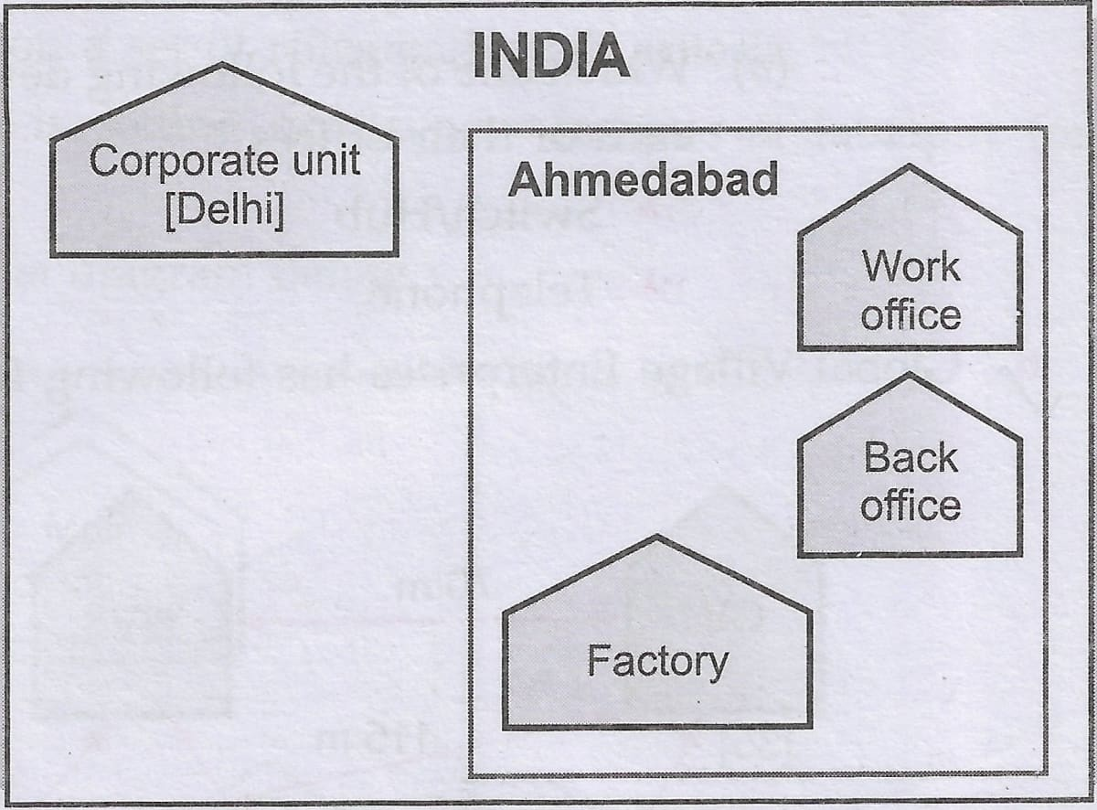
Approximate distance between these offices is as follows :
From | To | Distance
Work Office | Back Office | 110 m
Work Office | Factory | 14 km
Work Office | Corporate Office | 1280 km
Back Office | Factory | 13 km
In continuation of the above, the company experts have planned to install the following number of computers in each of their offices :
Work Office | 200
Back Office | 115
Factory | 67
Corporate | 75
(i) Suggest the kind of network required (out of LAN, MAN, WAN) for connecting each of the following offices:
- Work Office and Factory
- Work Office and Back Office
(ii) Which one of the following devices will you suggest for connecting all the computers within each of their office units ?
- Switch/Hub
- Modem
- Telephone
(iii) Which of the following communication media, you will suggest to be procured by the company for connecting their local offices in Ahmedabad for very effective (High Speed) communication ?
- Telephone Cable
- Optical Fibre
- Ethernet Cable
(iv) Suggest a cable/wiring layout for connecting the company's local office units located in Ahmedabad. Also, suggest an effective method/technology for connecting the company's office unit located in Delhi.
(v) Which one of the following devices will you suggest for connecting all the computers within each of their offices ?
- Switch/Hub
- Modem
- Telephone
Answer
(i) The kind of network required are:
- MAN should be used as the distance between the work office and factory is 14 km, which is greater than the geographical extent of LAN.
- LAN can be used as the distance between the Work Office and Back Office is less than 1 km.
(ii) Switch/Hub
(iii) Optical Fibre
(iv) Wiring layout for connecting the company's local office units located in Ahmedabad is shown below:
Work office - Factory - Back office
An effective method/technology for connecting the company's office unit located in Delhi is through satellite.
(v) Switch/Hub

Question 6
Global Village Enterprises has following four buildings in Hyderabad city :
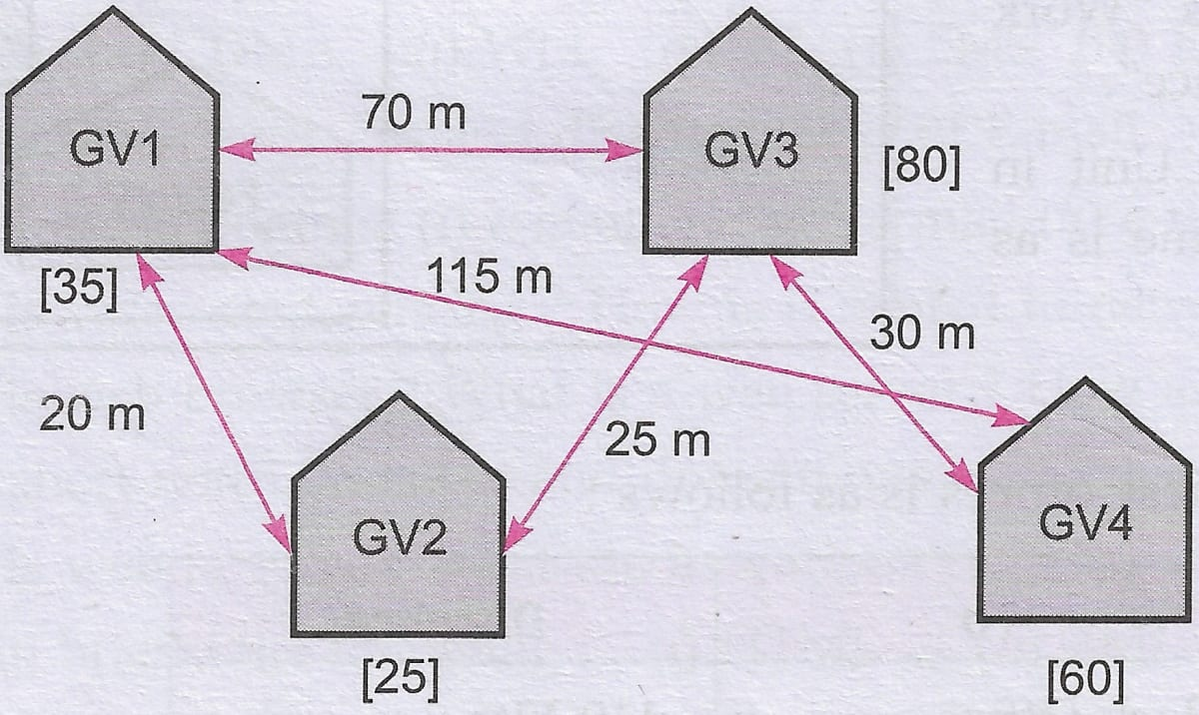
Computers in each building are networked but buildings are not networked so far. The company has now decided to connect buildings also.
(a) Suggest a cable layout for these buildings.
(b) In each of the buildings, the management wants that each LAN segment gets a dedicated bandwidth i.e., bandwidth must not be shared. How can this be achieved ?
(c) The company also wants to make available shared Internet access for each of the buildings. How can this be achieved ?
(d) The company wants to link its head office in GV1 building to its another office in Japan.
- Which type of transmission medium is appropriate for such a link ?
- What type of network would this connection result into ?
Answer
(a) The cable layout for these buildings is given below:
GV1 - GV2 - GV3 - GV4
(b) A dedicated bandwidth can be achieved by using switches as it does not share the media/bandwidth among all its connected computers.
(c) Switches will be able to provide shared Internet access for each of the buildings.
(d) To connect head office in GV1 building to Japan office:
- Satellite transmission would be appropriate.
- It will be a WAN connection.

Question 7
"China Middleton Fashion" is planning to expand their network in India, starting with two cities in India to provide infrastructure for distribution of their product. The company has planned to setup their main office in Chennai at three different locations and have named their offices as "Production Unit", "Finance Unit" and "Media Unit". The company has its corporate unit in Delhi. A rough layout of the same is shown on the right :
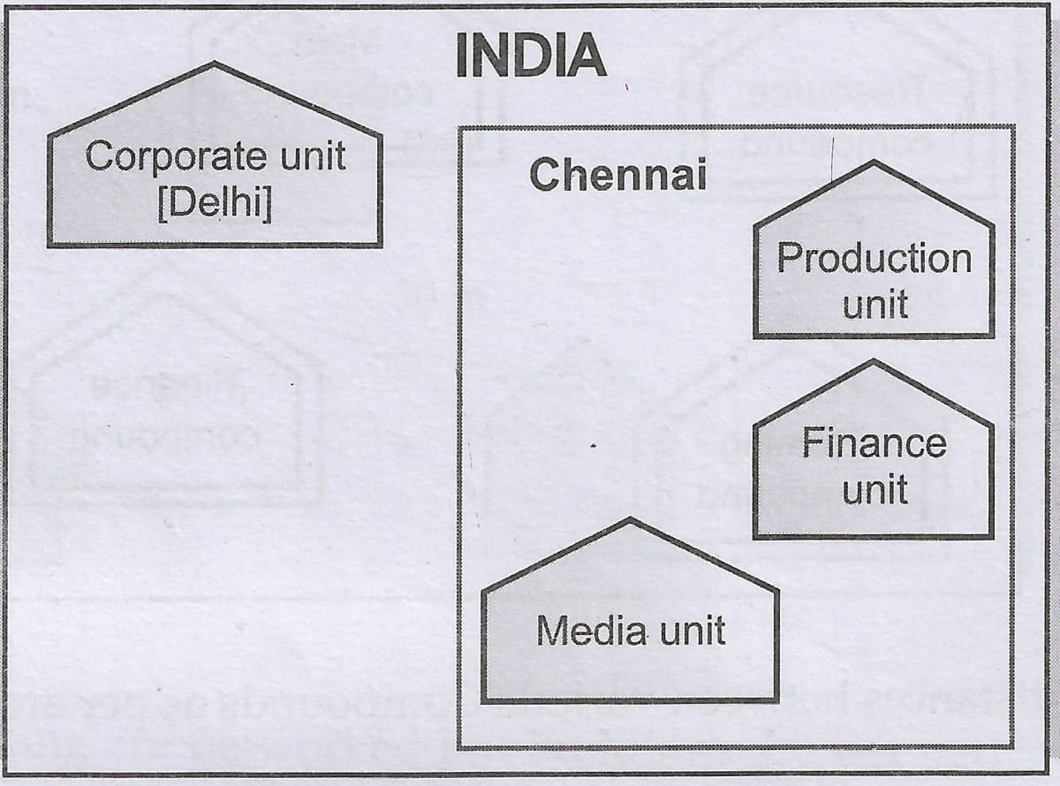
Approximate distance between these Units is as follows :
From | To | Distance
Production Unit | Finance Unit | 70 m
Production Unit | Media Unit | 15 km
Production Unit | Corporate Unit | 2112 km
Finance Unit | Media Unit | 15 km
In continuation of the above, the company experts have planned to install the following number of computers in each of their offices :
Production Unit | 150
Finance Unit | 35
Media Unit | 10
Corporate Unit | 30
(i) Suggest the kind of network required (out of LAN, MAN, WAN) for connecting each of the following office units :
- Production Unit and Media Unit
- Production Unit and Finance Unit
(ii) Which one of the following devices will you suggest for connecting all the computers within each of their office units ?
- Switch/Hub
- Modem
- Telephone
(iii) Which of the following communication media, you will suggest to be procured by the company for connecting their local office units in Chennai for very effective (High Speed) communication ?
- Telephone Cable
- Optical Fibre
- Ethernet Cable
(iv) Suggest a cable/wiring layout for connecting the company's local office units located in Chennai. Also, suggest an effective method/technology for connecting the company's office unit located in Delhi.
Answer
(i) The network used to connect :
- Production Unit and Media Unit is MAN as the distance is about 15 km.
- Production Unit and Finance Unit is LAN as the distance is less than 1 km.
(ii) Switch/Hub
(iii) Optical Fibre
(iv) Two possible cable/wiring layouts for connecting the company's local office units located in Chennai are given below:
Production Unit - Finance Unit - Media Unit
Media Unit - Production Unit - Finance Unit
Satellite links can be established for connecting the company's office unit located in Delhi.

Question 8
"Bhartiya Connectivity Association" is planning to spread their offices in four major cities in India to provide regional IT infrastructure support in the field of Education & Culture. The company has planned to setup their head office in New Delhi in three locations and have named their New Delhi offices as "Front Office", "Back Office" and "Work Office". The company has three more regional offices as "South Office", "East Office" and "West Office" located in other three major cities of India. A rough layout of the same is as follows :
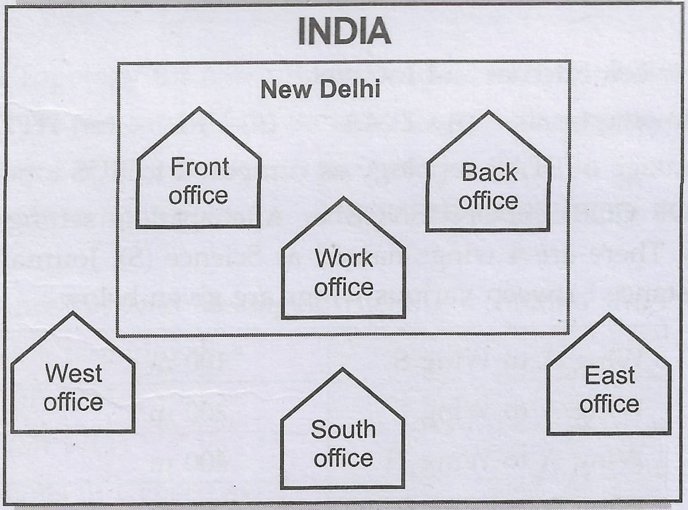
Approximate distances between these offices as per network survey team is as follows :
Place From | Place To | Distance
Back Office | Front Office | 10 km
Back Office | Work Office | 70 m
Back Office | East Office | 1291 km
Back Office | West Office | 790 km
Back Office | South Office | 1952 km
In continuation of the above, the company experts have planned to install the following number of computers in each of their offices :
Back Office | 100
Front Office | 20
Work Office | 50
East Office | 50
West Office | 50
South Office | 50
(i) Suggest network type (out of LAN, MAN, WAN) for connecting each of the following offices :
- Back Office and Work Office
- Back Office and South Office
(ii) Which device you will suggest to be produced by the company for connecting all the computers with in each of their offices out of the following devices ?
- Switch/Hub
- Modem
- Telephone
(iii) Which of the following communication medium, you will suggest to be procured by the company for connecting their local offices in New Delhi for very effective and fast communication ?
- Telephone Cable
- Optical Fibre
- Ethernet Cable
(iv) Suggest a cable/wiring layout for connecting the company's local offices located in New Delhi. Also, suggest an effective method/technology for connecting the company's regional offices-"East Office", "West Office" and "South Office" with offices located in New Delhi.
Answer
(i) The network types for connecting the offices :
- Back Office and Work Office through LAN as the distance is less than 1 km
- Back Office and South Office through WAN as the offices are very far from each other.
(ii) Switch/Hub
(iii) Optical Fibre
(iv) A cable/wiring layout for connecting the company's local offices located in New Delhi is given below:
Front office - Back office - Work office
Satellite links can be established for connecting the company's regional offices-"East Office", "West Office" and "South Office" with offices located in New Delhi.

Question 9
INDIAN PUBLIC SCHOOL in Darjeeling is setting up the network between its different wings. There are 4 wings named as SENIORS(S), JUNIOR(J), ADMIN(A) and HOSTEL(H).
Distance between various wings are given below :
Wing A to Wing S | 100 m
Wing A to Wing J | 200 m
Wing A to Wing H | 400 m
Wing S to Wing J | 300 m
Wing S to Wing H | 100 m
Wing J to Wing H | 450 m
Number of Computers
Wing A | 10
Wing S | 200
Wing J | 100
Wing H | 50
(i) Suggest a suitable Topology for networking the computer of all wings.
(ii) Name the wing where the server is to be installed. Justify your answer.
(iii) Suggest the placement of Hub/Switch in the network.
(iv) Mention an economic technology to provide internet accessibility to all wings.
Answer
(i) Star Topology can be used to network the computer of all wings.
(ii) The server should be installed in Wing S, as Wing S has maximum number of computers and installing the server in this wing will help to keep maximum percentage of the network traffic local.
(iii) Hub/ Switch will be required in all the Wings.
(iv) The economic way to provide internet accessibility to all wings is to use the proxy server at wing S and connect to the internet through a dial-up network.

Question 10
Eduminds University of India is starting its first campus in a small town Parampur of Central India with its center admission office in Delhi. The university has 3 major buildings comprising of Admin Building, Academic Building and Research Building in the 5 KM area Campus.
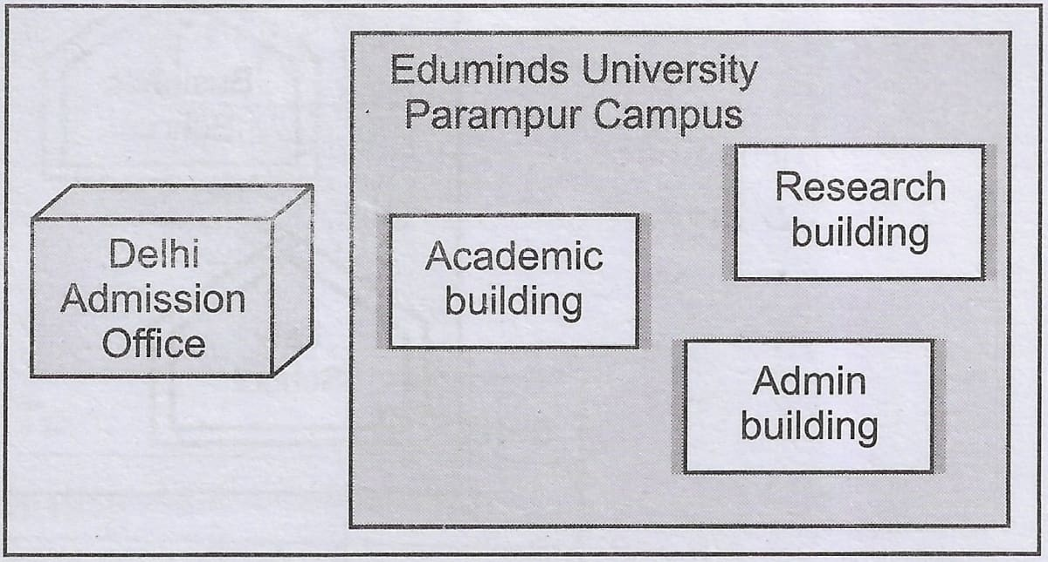
As a network expert, you need to suggest the network plan as per (1) to (4), keeping in mind the distances and other given parameters.
Expected Wire distances between various locations :
Research Building to Admin Building | 90 m
Research Building to Academic Building | 80 m
Academic Building to Admin Building | 15 m
Delhi Admission Office to Parampur Campus | 1450 km
Expected number of Computers to be installed at various locations in the University are as follows :
Research Building | 20
Academic Building | 150
Admin Building | 30
Delhi Admission Office | 5
(i) Suggest the authorities, the cable layout amongst various buildings inside the university campus for connecting the buildings.
(ii) Suggest the most suitable place (i.e., building) to house the server of this organisation, with a suitable reason.
(iii) Suggest an efficient device from the following to be installed in each of the buildings to connect all the computers :
- GATEWAY
- MODEM
- SWITCH
(iv) Suggest the most suitable (very high speed) service to provide data connectivity between Admission Building located in Delhi and the campus located in Parampur from the following options.
- Telephone line
- Fixed-Line Dial-up connection
- Co-axial Cable Network
- GSM
- Leased line
- Satellite Connection
Answer
(i) The cable layout amongst various buildings inside the university campus for connecting the buildings is given below:
Research building - Academic building - Admin building
(ii) The most suitable place to house the server is Academic Building as it has maximum number of computers. Thus, it decreases the cabling cost and keeps the maximum traffic local.
(iii) Switch can be installed in each of building to connect all the computers.
(iv) Satellite connection is the most suitable service to provide data connectivity between Admission Building located in Delhi and the campus located in Parampur.

Question 11
Great Studies University is setting up its Academic schools at Sunder Nagar and planning to set up a network. The university has 3 academic schools and one administration center as shown in the diagram below:
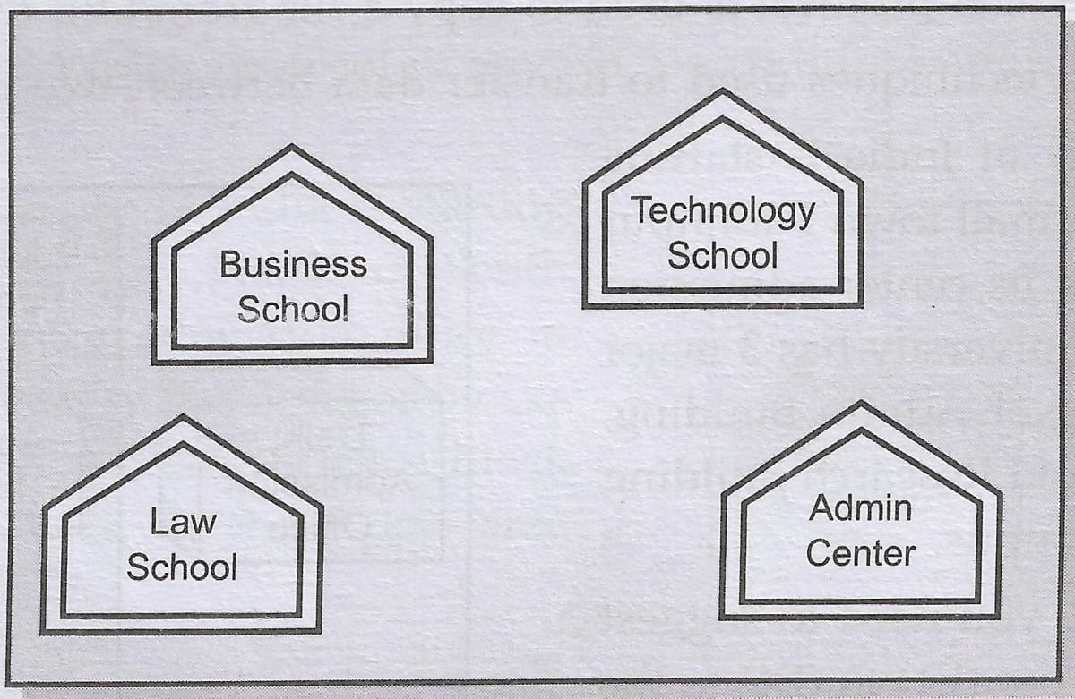
Center to center distances between various buildings are :
Law School to Business School | 60 m
Law School to Technology School | 90 m
Law School to Admin Center | 115 m
Business School to Technology School | 40 m
Business School to Admin Center | 45 m
Technology School to Admin Center | 25 m
No. of Computers in each of the buildings are :
Law School | 25
Technology School | 50
Admin Center | 125
Business School | 35
(a) Suggest the most suitable place (i.e., Schools/Center) to install the server of this university with a suitable reason.
(b) Suggest an ideal layout for connecting these Schools/center for a wired connectivity.
(c) Which device you will suggest to be placed/installed in each of these Schools/center to efficiently connect all the computers within these Schools/center ?
(d) The university is planning to connect its admission office in the closest big city, which is more than 350 km from the university. Which type of network out of LAN, MAN or WAN will be formed ? Justify your answer.
Answer
(a) The most suitable place to install the server is the Admin Center as it houses the maximum number of computers. Thus, reducing the cable cost and keeping most of the traffic local.
(b) An ideal layout for connecting these Schools/center for a wired connectivity is given below:
Law School - Business School - Technology School - Admin Center
(c) A hub/switch can be installed in each of these Schools/center to efficiently connect all the computers within these Schools/center.
(d) WAN will be formed as the distance between the admission office and the university is 350 km, which is more than the range of LAN and MAN.

Question 12
Expertia Professional Global (EPG) is an online corporate training provider company for IT related courses. The company is setting up their new campus in Mumbai. You as a network expert have to study the physical locations of various buildings and the number of computers to be installed. In the planning phase, provide the best possible answers for the queries (i) to (iv) raised by them.
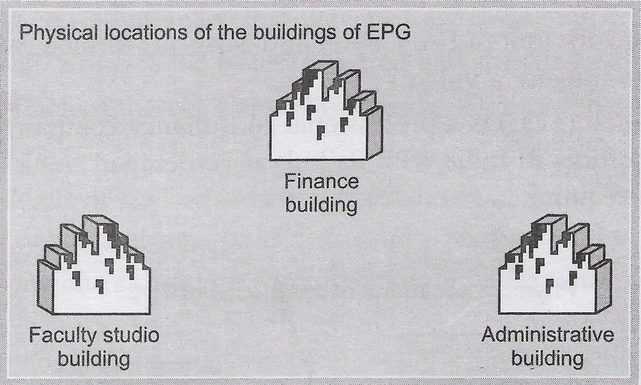
Building to Building Distance (in m) :
From | To | Distance
Admin. Building | Finance Building | 60
Admin. Building | Faculty Studio Building | 120
Finance Building | Faculty Studio Building | 70
Computers to be Installed in each Building :
Buildings | Computers
Admin. Building | 20
Finance Building | 40
Faculty Studio Building | 120
(i) Suggest the most appropriate building, where EPG should plan to install the server.
(ii) Suggest the most appropriate building cable layout to connect all three buildings for efficient communication.
(iii) Which type of network out of the following is formed by connecting the computers of the buildings?
- LAN
- MAN
- WAN
(iv) Which wireless channel out of the following should be opted by EPG to connect to students of all over the world ?
- Infrared
- Microwave
- Satellite
Answer
(i) EPG should install the server in Faculty Studio Building as it houses the maximum number of computers. Thus, it will reduce cable cost and keep maximum traffic local.
(ii) The most appropriate building cable layout to connect all three buildings for efficient communication is given below:
Administrative Building - Finance Building - Faculty Studio Building
(iii) LAN network is formed as the distance between the three buildings is less than 1 km.
(iv) Satellite communication should be opted by EPG to connect to students of all over the world.

